Compiler Design Lab

(RCS-652)

Laboratory Manual
For
Bachelor of Technology
In
Information Technology

Even Semester



Department of Information Technology
KRISHNA ENGINEERING COLLEGE
95, Loni Road, Mohan Nagar, Ghaziabad (Uttar Pradesh), Pin-201007

Course Outcomes of Compiler Design LAB
(RCS-652)

1.Abilty to create lexical rules and grammars for a programming language
2.Ability to use Flex or similar tools to create a lexical analyzer and Yacc/Bison tools to create a parser.
3.Ability to implement a lexer without using Flex or any other lexer generation tools.
4.Ability to implement a parser such as a bottom-up SLR parser without using Yacc/Bison or any other compiler-generation tools.
5.Ability to implement semantic rules into a parser that performs attribution while parsing.
6.Abilty to design a compiler for a concise programming language.

KRISHNA ENGINEERING COLLEGE
Department of Computer Science & Engineering

List of Practical’s

COMPILER DESIGN LAB (RCS-652)

S.No. | LIST OF PROGRAMS
1.  2.  3.  4.  5.  6.  7.  8.  9.  10.  11. | WAP to check whether the entered string is accepted or not for a given grammar.  WAP to convert infix expression to postfix expression.  WAP to convert infix expression to prefix expression.  WAP to find the no. of tokens and list them according to their category in an expression (given/entered)  WAP to construct an NFA from a regular expression (given) and display the transition table of NFA constructed.  WAP to compute LEADING and TRAILING sets of a grammar (given).  WAP to calculate FIRST and FOLLOW  WAP in C to check whether the Grammar is Left-recursive and remove left recursion  WAP in C to draw a SLR parsing table for a given grammar.  WAP in C to draw an operator precedence parsing table for the given grammar  WAP in C to draw a LL parsing table for a given grammar

Program 1

AIM: WAP to check whether the entered string is accepted or not for a given grammar.

PROGRAM:

Strings acceptable by grammar are of form: ab*c(a+b)
#include<stdio.h>
#include<conio.h>
#include<string.h>
#include<stdlib.h>

char a[100];
int n, i;

void main()
{

printf("\n enter string: ");
scanf("%s",&a);
n=strlen(a);

if(a[0]=='a' && (a[n-1]=='a' || a[n-1]=='b') && a[n-2]=='c')
{
for(i=1; i<n-2; i++)
{
if(a[i]!='b')
{
printf("\n string is not accepted");
getch();
exit(0);
}
}
printf("\n string is accepted");
}

else
printf("\n string is not accepted");

getch();
}

Output:
enter string: abbbca
string is accepted

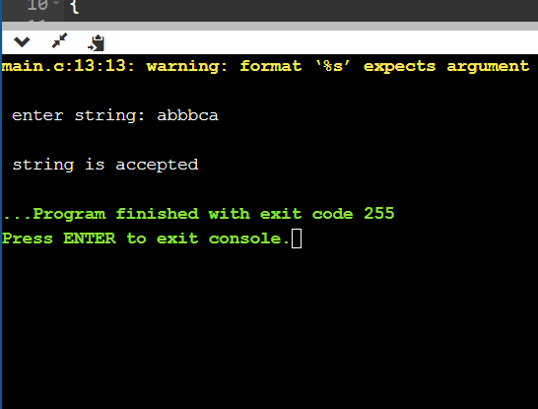

Program 2

AIM: WAP to convert infix expression to postfix expression.

Expression: A+(C*D)*F

PROGRAM:

#include<stdio.h>
#include<conio.h>
#include<string.h>

char str[]=”A+(C*D)*F”;
char stack[10];
int top=-1;

void push(char s)
{
top=top+1;
stack[top]=s;
}

char pop()
{
char item;
item=stack[top];
top--;
return(item);
}

int precede(char c)
{
if(c==47) // Division(/)
return(5);

if(c==42) // Multiplication(*)
return(4);

if(c==43) //Addition(+)
return(3);

else
return(2);
}

void main()
{
char postfix[10];
int l, i=0, j=0;
char s, temp;

printf(“infix string: “);
puts(str);

l=strlen(str);
push(‘#’);

while(i<l)
{
s=str[i];
switch(s)
{
case ‘(‘:
push(s);
break;

case ‘)’:
temp=pop();
while(temp!=’(‘)
{
postfix[j]=temp;
j++;
temp=pop();
}
break;

case ‘+’:
case ‘-‘:
case ‘*’:
case’/’:
while(precede(stack[top])>=precede(s))
{
temp=pop();
postfix[j]=temp;
j++;
}
push(s);
break;

default:
postfix[j++]=s;
break;
}
i++;
}

while(top>0)
{
temp=pop();
postfix[j++]=temp;
}

postfix[j++]=’\0’;

printf("\npostfix string");
puts(postfix);
getch();
}

Output:

infix string: a+b/c*d
postfix string: abc/d*+

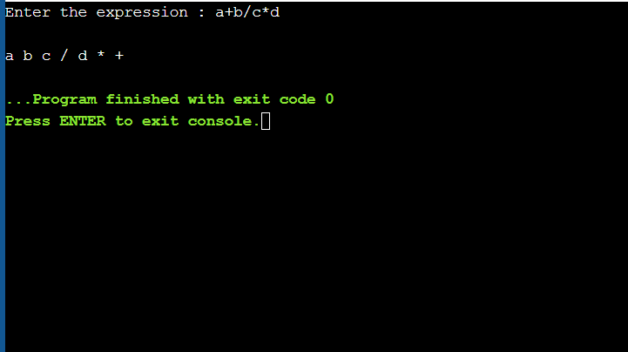
Program 3

AIM: WAP to convert infix expression to prefix expression.

PROGRAM:

#include<stdio.h>
#include<conio.h>
#include<string.h>

char str1[]="A+(C*D)*F";
char str[]="F*(D*C)+A";
char stack[10];
int top=-1;

void push(char s)
{
top=top+1;
stack[top]=s;
}

char pop()
{
char item;
item=stack[top];
top--;
return(item);
}

int precede(char c)
{
if(c==47) // Division(/)
return(5);

if(c==42) // Multiplication(*)
return(4);

if(c==43) //Addition(+)
return(3);

else
return(2);
}

void main()
{
char prefix[10];
int l, i=0, j=0;
char s, temp;

printf("infix string: ");
puts(str);

l=strlen(str);
push('#');

while(i<l)
{
s=str[i];
switch(s)
{
case '(':
push(s);
break;

case ')':
temp=pop();
while(temp!='(')
{
prefix[j]=temp;
j++;
temp=pop();
}
break;

case '+':
case '-':
case '*':
case '/':
while(precede(stack[top])>=precede(s))
{
temp=pop();
prefix[j]=temp;
j++;
}
push(s);
break;

default:
prefix[j++]=s;
break;
}
i++;
}

while(top>0)
{
temp=pop();
prefix[j++]=temp;
}

prefix[j++]='\0';

printf("\nprefix string");

for(i=6;i>=0;i--)
printf("%c", prefix[i]);

getch();
}

Output:

infix string: a+b/c*d
prefix string:+a*/bcd
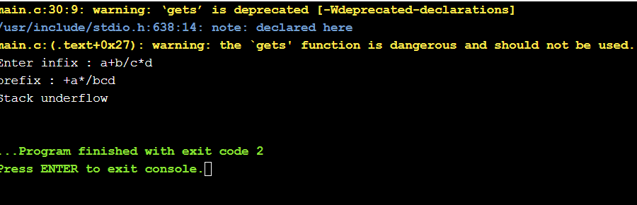
Program 4

AIM: WAP to find the no. of tokens and list them according to their category in an expression (given/entered)

PROGRAM:

Eg: a= b+c*23-56^2

#include<stdio.h>
#include<conio.h>
#include<ctype.h>

int con=0, var=0, op=0;

void check(char c)
{
if(isalpha(c))
var++;

if(c==47||c==42||c==43||c==45||c==61||c==94)
op++;
}

/* ASCII values:
/ -> 47
* -> 42
+ -> 43
- -> 45
= -> 61
^ -> 94
*/

void main()
{
char str[13];
char c;
int i=0;
printf("\nenter string: ");
scanf("%s", &str);

for(i=0; i<13; i++)
{
c=str[i];
check(c);
}

for(i=0; i<13; i++)
{
if(isdigit(str[i])&&isdigit(str[i+1]))
{
i=i+2;
con++;
}
else if(isdigit(str[i]))
con++;
}

printf("\n operators: %d \nvariables: %d \nconstants: %d" , op, var, con);
printf("\ntotal tokens=%d", op+var+con);
getch();

}

Output:

enter string
a=b+c*23-56^2

operators: 5
variables: 3
constants: 3
total tokens=11

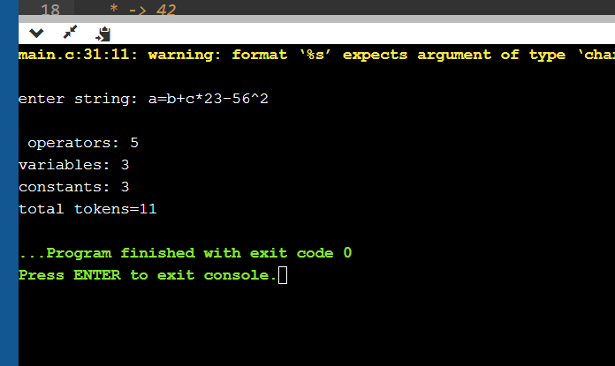

Program 5

AIM: WAP to construct an NFA from a regular expression (given) and display the transition table of NFA constructed.
- What is FSM.
- What is transition diagram.
- What is E transition.
- What is Thomsson rule.
Given regular expression: (a/b)*

PROGRAM:

#include<iostream.h>
#include<conio.h>
#include<stdio.h>
#include<string.h>
void main()
{
clrscr();
char s[10];
int n,init=0,fin=1;
cout<<"enter R.E\n";
gets(s);
n=strlen(s);
for(int i=0;i<n;i++)
{
if(s[i]=='*')
fin+=2;
if(s[i]=='.')
fin+=1;
if(s[i]=='/')
fin+=4;
}

char c=238;
i=0;
int ch;
if(s[0]>=97&&s[0]<=122)
ch=1;
if(s[0]=='('&&s[4]==')')
ch=2;
switch(ch)
{
case 1:
if(s[i+1]=='/')
{
if(s[i+2]>=97 && s[i+2]<=122)
{
cout<<"\n"<<init+2<<"--"<<s[i]<<"-->"<<init+3;
cout<<"\n"<<init+4<<"--"<<s[i+2]<<"-->"<<init+5;
goto pt1;
}
}

case 2:
if(s[i+1]>=97 && s[i+1]<=122)
if(s[i+2]=='/')
{
if(s[i+3]>=97 && s[i+3]<=122)
{
cout<<"\n"<<init+2<<"--"<<s[i+1]<<"-->"<<init+3;
cout<<"\n"<<init+4<<"--"<<s[i+3]<<"-->"<<init+5;

if(s[i+5]=='*')
{
goto pt;
}
else
goto pt1;
}
}
}

pt:
cout<<"\n"<<init<<"--"<<c<<"-->"<<init+1;
cout<<"\n"<<init<<"--"<<c<<"-->"<<fin;

pt1:
cout<<"\n"<<init+1<<"--"<<c<<"-->"<<init+2;
cout<<"\n"<<init+1<<"--"<<c<<"-->"<<init+4;
cout<<"\n"<<init+3<<"--"<<c<<"-->"<<init+6;
cout<<"\n"<<init+5<<"--"<<c<<"-->"<<init+6;
cout<<"\n"<<init+6<<"--"<<c<<"-->"<<init+1;
cout<<"\n"<<init+6<<"--"<<c<<"-->"<<fin;
getch();
}

- What is NFA

Output:

enter R.E
(a/b)*

2--a-->3
4--b-->5
0--î-->1
0--î-->7
1--î-->2
1--î-->4
3--î-->6
5--î-->6
6--î-->1
6--î-->7
Program 6

AIM: WAP to compute LEADING and TRAILING sets of a grammar(given).

Grammar: E→ E+T | T
T→ T*F | F
F→ (E) | id

PROGRAM :

#include<iostream.h>
#include<conio.h>
void main()
{
clrscr();
char s,l[20],r[10],lead[10],trail[10];
int n,j,m;
for(int i=0;i<10;i++)
{
lead[i]=NULL;
trail[i]=NULL;
}
cout<<"\nenter total no. of productions";
cin>>n;
int k=0;
m=0;
for(i=0;i<n;i++)
{
cout<<"\nenter the LHS of production";
cin>>l[i];
cout<<"\nenter the RHS of production";
cin>>r;
for(int j=0;j<2;j++)
{
if((r[j]=='(') || r[j]==')' || r[j]=='*' || r[j]=='+' || r[j]=='-' || r[j]=='/' )
{
lead[k]=r[j];
k=k+1;
}
if((r[j]=='i') && (r[j+1]=='d'))
{
lead[k]=r[j];
lead[k+1]=r[j+1];
k=k+1;
}
}
for(j=1;j<=2;j++)
{
if((r[j]=='(') || r[j]==')' || r[j]=='*' || r[j]=='+' || r[j]=='-' || r[j]=='/' )
{
trail[m]=r[j];
m=m+1;
}
if((r[j-1]=='i') && (r[j]=='d'))
{
trail[m]=r[j-1];
trail[m+1]=r[j];
m=m+1;
}
}

}
cout<<"\nthe Leading(A) is :\n";
cout<<"{ ";
for(i=0;i<k;i++)
{
if((lead[i]=='i') && (lead[i+1]=='d'))
cout<<lead[i]<<lead[i+1]<<" ";
else
cout<<lead[i]<<" ";
}
cout<<"}";
cout<<"\nthe Trailing(A) is :\n";
cout<<"{ ";
for(i=0;i<m;i++)
{
if((trail[i]=='i') && (trail[i+1]=='d'))
cout<<trail[i]<<trail[i+1]<<" ";
else
cout<<trail[i]<<" ";
}
cout<<"}";

getch();
}

Output:

enter total no. of productions: 6

enter the LHS of production: E
enter the RHS of production: E+T

enter the LHS of production: T
enter the RHS of production: T*F

enter the LHS of production: T
enter the RHS of production: F

enter the LHS of production: E
enter the RHS of production: T

enter the LHS of production: F
enter the RHS of production: (E)

enter the LHS of production :F
enter the RHS of production: id

the Leading(A) is :
{ + * ( id }
the Trailing(A) is :
{ + * ) id }

Program 8

AIM: WAP to calculate FIRST and FOLLOW.

PROGRAM:

#include<stdio.h>
#include<conio.h>

char FT[5];
char FL[5];

void checkfirst(char x)
{
int i=0;
switch(x)
{
case 'a':
FT[i]='a'; i++;
break;

case 'b':
FT[i]='b'; i++;
break;

case 'e':
FT[i]='e'; i++;
break;

case ')':
FT[i]=')'; i++;
break;

case 'i':
FT[i]='i'; i++;
break;

case '@':
FT[i]='@'; i++;
break;
}
}

void checkfollow(char x)
{
int i=0;
switch(x)
{
case 'a':
FT[i]='a'; i++;

break;
case 'b':
FT[i]='b'; i++;

break;
case 'e':
FT[i]='e'; i++;
break;

case 't':
FL[i]='t'; i++;
break;

case 'i':
FT[i]='i'; i++;
break;

case '@':
FT[i]='@'; i++;
break;
}
}

void first(char y)
{ int i;
checkfirst(y);
for(i=0;i<2;i++)
printf("%c", FT[i]);
}

void follow(char y)
{ int i;
FL[0]='$';
if(y=='e')
first(y);

checkfollow(y);
for(i=0;i<2;i++)
printf("%c", FL[i]);
}

void main()
{
int i;
char S1[]="iCtSS'";
char S2[]="a";
char s1[]="eS'";
char s2[]="@";
char C1[]="b";
char X[]="tS";
char t1,t2,e1,e2,c1,x;
t1=S1[0];
t2=S2[0];
e1=s1[0];
e2=s2[0];
c1=C1[0];
x=X[0];

clrscr();
printf("\nFIRST [S]: ");
first(t1);
first(t2);
printf("\n\nFIRST [S']: ");
first(e1);
first(e2);
printf("\n\nFIRST [C]: ");
first(c1);

printf("\n\nFOLLOW [S]: ");
follow(e1);

printf("\n\nFOLLOW [S']: ");
follow(e1);

printf("\n\nFOLLOW [C]: ");
follow(x);

getch();
}

Output:

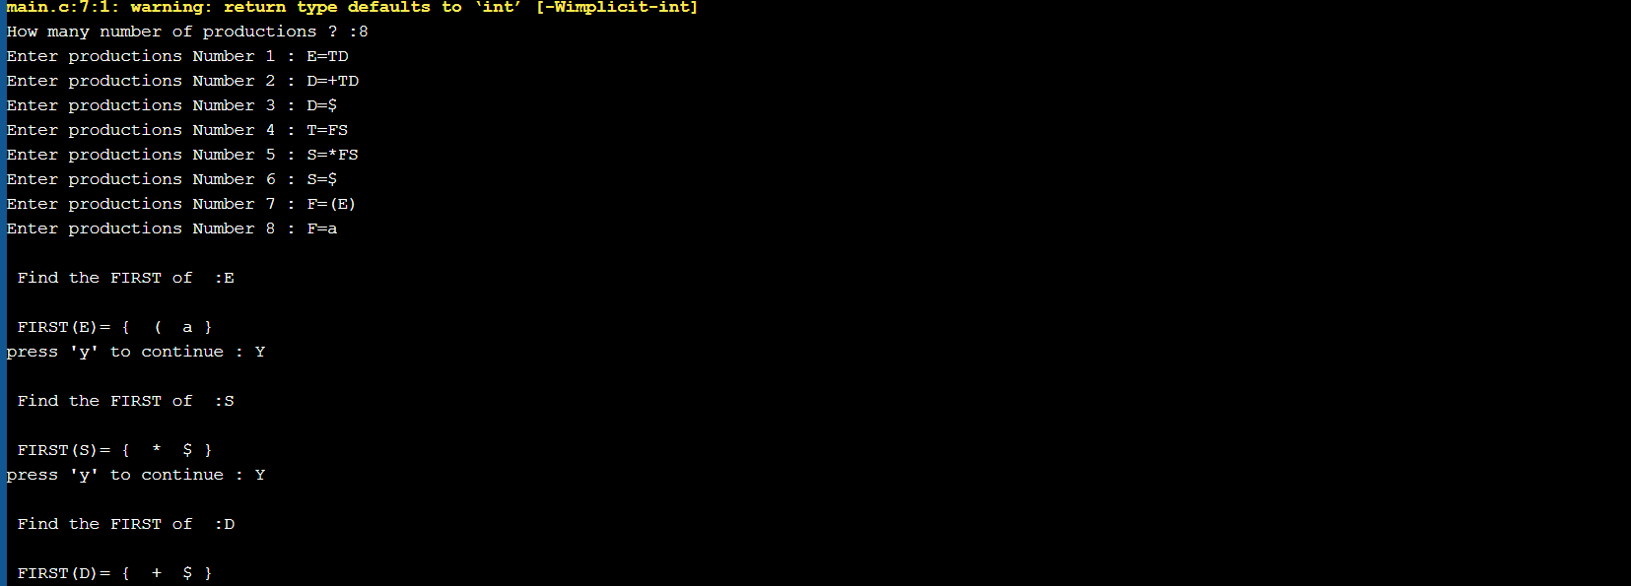

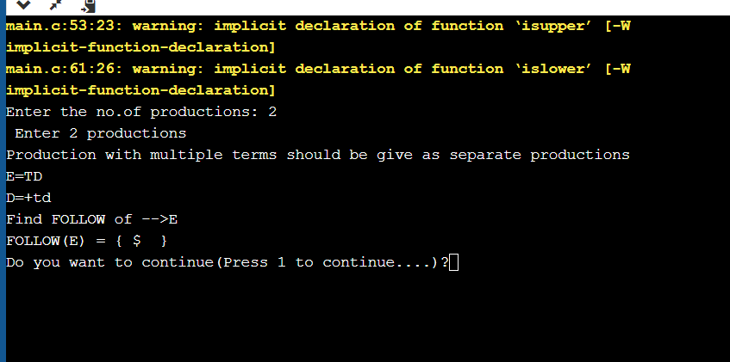

Program 9

AIM: WAP in C to check whether the Grammar is Left-recursive and remove left recursion.

PROGRAM:

#include<iostream.h>
#include<stdio.h>
#include<conio.h>
#include<string.h>

struct production
{
char l;
char r[10];
int rear;
};
struct production prod[20],pr_new[20];

int p=0,b=0,d,f,q,n,flag=0;
char terminal[20],nonterm[20],alpha[10];
char x,epsilon='^';

void main()
{
clrscr();

cout<<"Enter the number of terminals: ";
cin>>d;
cout<<"Enter the terminal symbols for your production: ";
for(int k=0;k<d;k++)
{
cin>>terminal[k];
}

cout<<"\nEnter the number of non-terminals: ";
cin>>f;
cout<<"Enter the non-terminal symbols for your production: ";
for(k=0;k<f;k++)
{
cin>>nonterm[k];
}

cout<<"\nEnter the number of Special characters(except non-terminals): ";
cin>>q;
cout<<"Enter the special characters for your production: ";
for(k=0;k<q;k++)
{
cin>>alpha[k];
}

cout<<"\nEnter the number of productions: ";
cin>>n;
for(k=0;k<=n-1;k++)
{
cout<<"Enter the "<< k+1<<" production: ";
cin>>prod[k].l;
cout<<"->";
cin>>prod[k].r;
prod[k].rear=strlen(prod[k].r);
}

for(int m=0;m<f;m++)
{
x=nonterm[m];
for(int j=0;j<n;j++)
{
if((prod[j].l==x)&&(prod[j].r[0]==prod[j].l))
flag=1;
}
for(int i=0;i<n;i++)
{
if((prod[i].l==x)&&(prod[i].r[0]!=x)&&(flag==1))
{
pr_new[b].l=x;
for(int c=0;c<prod[i].rear;c++)
pr_new[b].r[c]=prod[i].r[c];
pr_new[b++].r[c]=alpha[p];
}
else if((prod[i].l==x)&&(prod[i].r[0]==x)&&(flag==1))
{
pr_new[b].l=alpha[p];
for(int a=0;a<=prod[i].rear-2;a++)
pr_new[b].r[a]=prod[i].r[a+1];
pr_new[b++].r[a]=alpha[p];
pr_new[b].l=alpha[p];
pr_new[b++].r[0]=epsilon;
}
else if((prod[i].l==x)&&(prod[i].r[0]!=x)&&(flag==0))
{
pr_new[b].l=prod[i].l;
strcpy(pr_new[b].r,prod[i].r);
b++;
}
}
flag=0;
p++;
}

cout<<"\n\n*******************************************";
cout<<"\n AFTER REMOVING LEFT RECURSION ";
cout<<"\n*******************************************"<<endl;
for(int s=0;s<=b-1;s++)
{
cout<<"Production "<<s+1<<" is: ";
cout<<pr_new[s].l;
cout<<"->";
cout<<pr_new[s].r;
cout<<endl;
}

getche();
}

Output
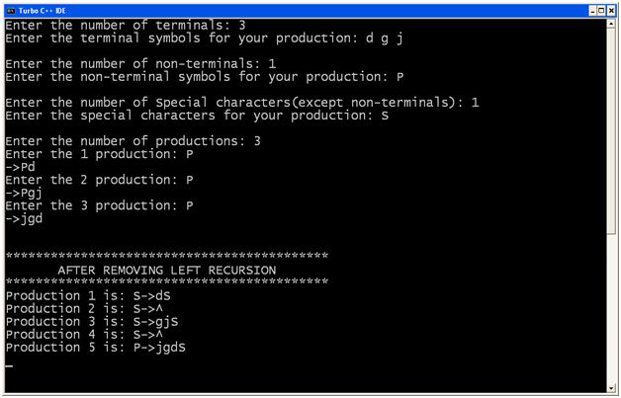

Prgramm-10

AIM: WAP in C to draw a SLR parsing table for a given grammar

PROGRAM:

#include<stdio.h>
#include<ctype.h>
#include<conio.h>
#include<stdlib.h>
#include<string.h>
#include<iostream.h>

#define epsilon '^'

// since I didn't know how to type epsilon symbol temporily I am using ^

char prod[20][20],T[20],NT[20],c[10][10],foll[10][10],fir[10][10];
int tt,tnt,tp,a;
int follow[20][20],first[20][20];
void first_of(char);
int count(int j);
void rhs(int j);
void read_tnt();
int rhs(int j);

void read_tnt()
{
cout<<"For SLR parser: ";
cout<<"\nEnter number of terminals: ";
cin>>tt;
cout<<"\nEnter terminals: ";
for(int i=0;i<tt;i++)
T[i]=getche();
getch();
cout<<"\nEnter number of Non-terminals: ";
cin>>tnt;
cout<<"\nEnter Non-terminals: ";
for(i=0;i<tnt;i++)
NT[i]=getche();
getch();
}

void read_prod()
{
int j;
char x=0;
cout<<"\n\nEnter number of productions: ";
cin>>tp;
cout<<"\n Enter productions: ";
for(int i=0;i<tp;i++)
{
j=x=0;
while(x!='\r')
{
prod[i][j]=x=getche();
j++;
}
cout<<"\n";
}
getch();
}

int nt_no(char n)
{
for(int i=0;i<tnt;i++)
if(NT[i]==n)
return(i);
return(-1);
}

int t_no(char t)
{
for(int i=0;i<tt;i++)
if(T[i]==t)
return(i);
if(t=='$')
return(tt);
return(-1);
}

int terminal(char x)
{
for(int i=0;i<tt;i++)
if(T[i]==x)
return(1);
return(0);
}

int nonterminal(char x)
{
for(int i=0;i<tnt;i++)
if(NT[i]==x)
return(1);
return(0);
}

int in_rhs(char *s,char x)
{
for(int i=0;i<=strlen(s);i++)
if(*(s+i)==x)
return(i);
return(-1);
}

void find_first()
{
for(int i=0;i<tnt;i++)
first_of(NT[i]);
}

void first_of(char n)
{
int t1,t2,p1,cnt=0,i,j;
char x;
static int over[20];
p1=t_no(epsilon);
if(terminal(n))
return;
t1=nt_no(n);
if(over[t1])
return;
over[t1]=1;
for(i=0;i<tp;i++)
{
t1=nt_no(prod[i][0]);
if(prod[i][0]==n)
{
int k=0;
cnt=count(1);
rhs(i);
while(k<cnt)
{
x=c[i][k];
if(terminal(x))
{
t2=t_no(x);
first[t1][t2]=1;
break;
}
else
{
t2=nt_no(x);
first_of(x);
for(int j=0;j<tt;j++)
if(p1!=j && first[t2][j])
first[t1][j]=1;
if(p1!=-1 && first[t2][p1])
k++;
else
break;
}
}
if(p1!=-1 && k>=cnt)
first[t1][p1]=1;
}
}
}

void follow_of(char n)
{
int f,t1,t2,p1,t,cnt=0;
char x,beta;
static int over[20];
p1=t_no(epsilon);
t1=nt_no(n);
if(over[t1])
return;
over[t1]=1;
if(NT[0]==n)
follow[nt_no(NT[0])][tt]=1;
for(int i=0;i<tp;i++)
{
rhs(i);
cnt=count(i);
t=in_rhs(c[i],n);
if(t==-1)
continue;
for(int k=t+1;k<=cnt;k++)
{
rhs(i);
beta=c[i][k];
if(terminal(beta))
{
t2=t_no(beta);
follow[t1][t2]=1;
break;
}
int bno;
for(int j=0;j<tt;j++)
{
bno=nt_no(beta);
if((first[bno][j]) && (j!=p1))
follow[t1][j]=1;
}
if((p1!=-1) && (first[bno][p1]==1))
continue;
else if((t==(cnt-1)||(k>=cnt)))
{
follow_of(prod[i][0]);
t1=nt_no(prod[i][0]);
for(int l=0;l<=tt+1;l++)
if(follow[t][l])
follow[t1][l]=1;
}
}
}
}

int count(int j)
{
int c1=0;
for(int q=3;prod[j][q]!='\r';q++)
c1++;
return(c1);
}

void rhs(int j)
{
int a,h=0;
a=j;
for(int q=3;prod[j][q]!='\r';q++)
{
c[a][h]=prod[j][q];
h++;
}
}

void find_follow()
{
for(int i=0;i<tnt;i++)
follow_of(NT[i]);
}

void show_follow()
{
int b=0;
a=0;
cout<<"\n\n Follow Table For Grammar: \n";
for(int i=0;i<tnt;i++)
{
b=0;
cout<<"\n FOLLOW ("<<NT[i]<<" )= { ";
for(int j=0;j<tt+1;j++)
if(follow[i][j] && j!=tt)
{
foll[a][b]=T[j];
b++;
cout<<T[j]<<" ";
}
else
if(j==tt)
{
foll[a][b]='$';
b++;
cout<<'$';
}
a++;
cout<<" } ";
}
getch();
}
void show_first()
{
int b=0;
a=0;
cout<<"\n\n First Table For Grammar: \n";
for(int i=0;i<tnt;i++)
{
b=0;
cout<<"\n FIRST ("<<NT[i]<<" )= { ";
for(int j=0;j<tt+1;j++)
if(first[i][j] && j!=tt)
{
fir[a][b]=T[j];
b++;
cout<<T[j]<<" ";
}
a++;
cout<<" } ";
}
getch();
}

void mainf(void)
{
clrscr();
read_tnt();
read_prod();
find_first();
find_follow();
show_follow();
show_first();
}

To construct parse table:

#include<stdio.h>
#include<conio.h>
#include<string.h>
#include<ctype.h>
#include<stdlib.h>
#include<iostream.h>

#include"c:\tc\bin\SLR.h"

int S=0,i=0,j=0,state[20];
char TNT[15];

struct node
{
int pno,dpos;
};
struct t
{
char s;
int n;
};
struct t1
{
struct t lr[10];
int gr[5];
};
struct t1 action[15];
struct node closure[10][10];
int g[15][10];
int l;

void sclosure(int,int);
int added(int);
int t_into(char);
void print_table(int);
void parser(void);
int find_index(char);
int t_ino(char);
void pop(void);

void push(char,int);
void find_closure(int,int);
void SLR(void);

void main()
{
clrscr();
mainf();
getch();
for(int i=0;i<tnt;i++)
TNT[i]=NT[i];
for(int j=0;j<tt;j++)
{
TNT[i]=T[j];
i++;
}
strcat(T,"$");
i=j=0;
SLR();
print_table(S);
getch();
// clrscr();
// parser();
// getch();
}

void SLR()
{
int clno,no=0,x,y,z,len,cnt=-1,d=0;
closure[i][j].pno=0;
closure[i][j++].dpos=3;
find_closure(no,3);
sclosure(i,j);
state[i]=j;
S=0;
do
{
cnt++;
z=state[cnt];
for(int k=0;k<tnt+tt;k++)
{
i++;
j=0;d=0;
for(int l=0;l<z;l++)
{
x=closure[cnt][1].pno;
y=closure[cnt][1].dpos;
if(prod[x][y]==TNT[k])
{
d=1;
closure[i][j].pno=x;
closure[i][j++].dpos=++y;
if((y<strlen(prod[x])) && (isupper(prod[x][y])))
find_closure(x,y);
}
}
if(d==0)
{
i--;
continue;
}
sclosure(i,j);
state[i]=j;
clno=added(i-1);
if(clno==-1)
clno=i;
if(isupper(TNT[k]))
action[cnt].gr[k]=clno;
else
{
action[cnt].lr[k-tnt].s='S';
action[cnt].lr[k-tnt].n=clno;
}
if(added(i-1)!=-1)
i--;
else
{
S++;
for(l=0;l<state[i];l++)
{
if(closure[i][1].pno==0)
{
action[i].lr[tt].s='A';
continue;
}
len=(strlen(prod[closure[i][l].pno])-1);
if(len==closure[i][l].dpos)
{
char v=prod[closure[i][l].pno][0];
int u=nt_no(v);
for(x=0;x<strlen(foll[u]);x++)
{
int w=t_ino(foll[u][x]);
action[i].lr[w].s='R';
action[i].lr[w].n=closure[i][l].pno;
}
}
}
}
}
}
while(cnt!=S);
}

void print_table(int states)
{
int lin=5;
cout<<"\n\n Parser Table: \n";
for(int i=0;i<tt;i++)
cout<<"\t"<<T[i];
cout<<"\t$";
for(i=0;i<tnt;i++)
cout<<"\t"<<NT[i];
cout<<"\n______________________________________________________________\n";
for(i=0;i<=states;i++)
{
gotoxy(l,lin);
cout<<"I"<<i<<"\t";
for(int j=0;j<=tt;j++)
{
if(action[i].lr[j].s!='\x0')
{
if(action[i].lr[j].s=='A')
{
cout<<"Acc";
continue;
}
cout<<action[i].lr[j].s;
cout<<action[i].lr[j].n;
cout<<"\t";
}
else
cout<<"\t";
}
for(j=0;j<tnt;j++)
if(action[i].gr[j])
{
cout<<action[i].gr[j];
cout<<"\t";
}
else
cout<<"\t";
lin++;
cout<<"\n";
}
cout<<"\n______________________________________________________";
}
void sclosure(int clno,int prodno)
{
struct node temp;
for(int i=0;i<prodno-1;i++)
{
for(int j=i+1;j<prodno;j++)
{
if(closure[clno][i].pno>closure[clno][j].pno)
{
temp=closure[clno][i];
closure[clno][i]=closure[clno][j];
closure[clno][j]=temp;
}
}
}
for(i=0;i<prodno-1;i++)
{
for(j=i+1;j<prodno;j++)
{
if((closure[clno][i].dpos>closure[clno][j].dpos) &&
(closure[clno][i].pno==closure[clno][j].pno))
{
temp=closure[clno][i];
closure[clno][i]=closure[clno][j];
closure[clno][j]=temp;
}
}
}
}

int added(int n)
{
int d=1;
for(int k=0;k<=n;k++)
{
if(state[k]==state[n+1])
{
d=0;
for(int j=0;j<state[k];j++)
{
if((closure[k][j].pno!=closure[n+1][j].pno) ||
(closure[k][j].dpos!=closure[n+1][j].dpos))
break;
else
d++;
}
if(d==state[k])
return(k);
}
}
return(-1);
}

void find_closure(int no,int dp)
{
int k;
char temp[5];
if(isupper(prod[no][dp]))
{
for(k=0;k<tp;k++)
{
if(prod[k][0]==prod[no][dp])
{
closure[i][j].pno=k;
closure[i][j++].dpos=3;
if(isupper(prod[k][3])&&
(prod[k][3]!=prod[k][0]))
find_closure(k,3);
}
}
}
return;
}

int t_ino(char t)
{
for(int i=0;i<=tt;i++)
if(T[i]==t)
return(i);
return(-1);
}

char pops2;
struct node1
{
char s2;int s1;
};
struct node1 stack[10];
int pops1,top=0;

void parser(void)
{
int r,c;
struct t lr[10];
char t,acc='f',str[10];
cout<<"Enter I/p String To Parse: ";
cin>>str;
strcat(str,"$");
stack[0].s1=0;
stack[0].s2='\n';
cout<<"\n\n STACK";
cout<<"\t\t INPUT";
cout<<"\t\t ACTION";
cout<<"\n =====";
cout<<"\t\t =======";
cout<<"\t\t =======";
i=0;
cout<<"\n";
cout<<stack[top].s1;
cout<<" \t\t\t ";
for(int j=0;j<strlen(str);j++)
cout<<str[j];
do
{
r=stack[top].s1;
c=find_index(str[i]);
if(c==-1)
cout<<"\n Error! Invalid String!";
return;
}
while(top!=0);
switch(action[r],lr[c].s)
{
case 'S':
{
push(str[i],action[r].lr[c].n);
i++;
cout<<"\t\t\t Shift";
break;
}
case 'R':
{
t=prod[action[r].lr[c].n][3];
do
{
pop();
}
while(pops2!=t);
t=prod[action[r].lr[c].n][0];
r=stack[top].s1;
c=find_index(t);
push(t,action[r].gr[c-tt-1]);
cout<<"\t\t\t Reduce";
break;
}
case 'A':
{
cout<<"\t\t\t Accept";
cout<<"\n\n\n String accepted";
acc='t';
getch();
return;
}
default:
{
cout<<"\n\n\n Error! String not accepted!";
getch();
exit(0);
}
}
for(j=0;j<=top;j++)
cout<<stack[j].s2<<stack[j].s1;
if(top<4)
cout<<"\t\t\t";
else
cout<<"\t\t";
for(j=i;j<strlen(str);j++)
cout<<str[j];
if(acc=='t')
return;
}

int find_index(char temp)
{
for(int i=0;i<=tt+tnt;i++)
{
if(i<=tt)
{
if(T[i]==temp)
return(i);
}
else
if(NT[i-tt-1]==temp)
return(i);
}
return(-1);
}

void push(char t2,int t1)
{
++top;
stack[top].s1=t1;
stack[top].s2=t2;
return;
}

void pop(void)
{
pops1=stack[top].s1;
pops2=stack[top].s2;
--top;
return; }
Output :
Enter number of terminals: 5
Enter terminals:+*()i
Enter number of non-terminals:3
Enter non-terminals:ETF
Enter number of productions:6
Enter productions:
E->E+T
E->T
T->T*F
T->F
F->(E)
F->i

Follow table:
FOLLOW(E)={+ ) $}
FOLLOW(F)={+ * ) $}
FOLLOW(T)={ + * ) $}

First Table :
FIRST(E)={ ( i }
FIRST(E)={ ( i }
FIRST(E)={ ( i }
Expected parse table:

+ * ( ) i $ E T F

I0 S4 S5 1 2 3
I1 S6 ACC
I2 R1 S7 R1 R1
I3 R3 R3 R3 R3
I4 S4 S5 ACC 8 2 3
I5 R5 R5 R5 R5
I6 ACC
I7 S4 S5 9
I8 S10 S11 ACC
I9 R2 R2 R2 R2
I10 ACC
I11 R4 R4 R4 R4

Enter i/p string: i+i*i

STACK INPUT ACTION

0 i+i*i$ Shift
0i5 +i*i$ Reduce
0F3 +i*i$ Reduce
0T2 +i*i$ Reduce
0E1 +i*i$ Shift
0E1+6 i*i$ ERROR! STRING NOT ACCEPTED!

Program 11

AIM: WAP in C to draw an operator precedence parsing table for the given grammar

PROGRAM:

#include<conio.h>
#include<stdio.h>
#include<stdlib.h>

int getOperatorPosition(char );

#define node struct tree1

int matrix[5][5]={
{1,0,0,1,1},
{1,1,0,1,1},
{0,0,0,2,3},
{1,1,3,1,1},
{0,0,0,3,2}};
int tos=-1;
void matrix_value(void);
//node create_node(char,*node);void show_tree( node *);
int isOperator(char );

struct tree1
{
char data;
node *lptr;
node *rptr;
}*first;

struct opr
{
char op_name;
node *t;
}oprate[50];

char cur_op[5]={'+','*','(',')','['};
char stack_op[5]={'+','*','(',')',']'};

void main()
{
char exp[10];

int ssm=0,row=0,col=0;
node *temp;
// clrscr();

printf("Enter Exp : ");
scanf("%s",exp);

matrix_value();
while(exp[ssm] != '\0')
{
if(ssm==0)
{
tos++;
oprate[tos].op_name = exp[tos];
}
else
{
if(isOperator(exp[ssm]) == -1)
{
oprate[tos].t = (node*) malloc (sizeof(node));
oprate[tos].t->data = exp[ssm];
oprate[tos].t->lptr = '\0';
oprate[tos].t->rptr = '\0';
}
else
{
row = getOperatorPosition(oprate[tos].op_name);
col = getOperatorPosition(exp[ssm]);
if(matrix[row][col] == 0)
{
tos++;
oprate[tos].op_name = exp[ssm];
}
elseif(matrix[row][col] == 1)
{
temp = (node*) malloc (sizeof(node));
temp->data = oprate[tos].op_name;

temp->lptr = (oprate[tos-1].t);
temp->rptr = (oprate[tos].t);
tos--;
oprate[tos].t = temp;
ssm--;
}
elseif(matrix[row][col] == 2)
{
//temp = (node*) malloc (sizeof(node));
temp = oprate[tos].t;
tos--;
oprate[tos].t = temp;
}
elseif(matrix[row][col] == 3)
{
printf("\nExpression is Invalid...\n");
printf("%c %c can not occur simultaneously\n",oprate[tos].op_name,exp[ssm]);
break;
}
}

}

ssm++;
}
printf("show tree \n\n\n");
show_tree(oprate[tos].t);
printf("Over");
getch();
getch();
}

int isOperator(char c)
{
int i=0;
for(i=0;i<5;i++)
{
if (c==cur_op[i] || c==stack_op[i])
break;
}

if(i==5)
return (-1);
elsereturn i;

}
int getOperatorPosition(char c)
{
int i;
for(i=0;i<5;i++)
{
if (c==cur_op[i] || c==stack_op[i])
break;
}
return i;

}

void show_tree(node *start)
{
if(start->lptr != NULL)
show_tree(start->lptr);

if(start->rptr != NULL)
show_tree(start->rptr);

printf("%c \n",start->data);
}

void matrix_value(void)
{
int i,j;
printf("OPERATOR PRECEDENCE MATRIX\n");
printf("===========================\n ");

for(i=0; i<5; i++)
{
printf("%c ",stack_op[i]);
}
printf("\n");

for(i=0;i<5;i++)
{
printf("%c ",cur_op[i]);
for(j=0;j<5;j++)
{
if(matrix[i][j] == 0)
printf("< ");
elseif(matrix[i][j] == 1)
printf("> ");
elseif(matrix[i][j] == 2)
printf("= ");
elseif(matrix[i][j] == 3)
printf(" ");
}
printf("\n");
}

}
OUTPUT:
***********************************/
Enter Exp : [a+b*c]
OPERATOR PRECEDENCE MATRIX
===========================
+ * ( ) ]
+ > < < > >
* > > < > >
( < < < =
) > > > >
[ < < < =
show tree

a
b
c
*
+
Over
Enter Exp : [a+(b*c)+d]
OPERATOR PRECEDENCE MATRIX
===========================
+ * ( ) ]
+ > < < > >
* > > < > >
( < < < =
) > > > >
[ < < < =
show tree

a
b
c
*
+
d
+
Over
Enter Exp : [)]
OPERATOR PRECEDENCE MATRIX
===========================
+ * ( ) ]
+ > < < > >
* > > < > >
( < < < =
) > > > >
[ < < < =

Program-12

AIM: WAP in C to draw a LL parsing table for a given grammar

PROGRAM:

#include <iostream.h>
#include <conio.h>
#include <string.h>
#include <stdio.h>
#include <stdlib.h>
void main()
{
clrscr();
int i=0,j=0,k=0,m=0,n=0,o=0,o1=0,var=0,l=0,f=0,c=0,f1=0;
char str[30],str1[40]="E",temp[20],temp1[20],temp2[20],tt[20],t3[20];
strcpy(temp1,'\0');
strcpy(temp2,'\0');
char t[10];
char array[6][5][10] = {
"NT", "<id>","+","*",";",
"E", "Te","Error","Error","Error",
"e", "Error","+Te","Error","\0",
"T", "Vt","Error","Error","Error",
"t", "Error","\0","*Vt","\0",
"V", "<id>","Error","Error","Error"
};
cout << "\n\tLL(1) PARSER TABLE \n";
for(i=0;i<6;i++)
{
for(j=0;j<5;j++)
{
cout.setf(ios::right);
cout.width(10);
cout<<array[i][j];
}
cout<<endl;
}
cout << endl;
cout << "\n\tENTER THE STRING :";
gets(str);
if(str[strlen(str)-1] != ';')
{
cout << "END OF STRING MARKER SHOULD BE ';'";
getch();
exit(1);
}
cout << "\n\tCHECKING VALIDATION OF THE STRING ";
cout <<"\n\t" << str1;
i=0;

while(i<strlen(str))
{
again:
if(str[i] == ' ' && i<strlen(str))
{
cout << "\n\tSPACES IS NOT ALLOWED IN SOURSE STRING ";
getch();
exit(1);
}
temp[k]=str[i];
temp[k+1]='\0';
f1=0;
again1:
if(i>=strlen(str))
{
getch();
exit(1);
}
for(int l=1;l<=4;l++)
{
if(strcmp(temp,array[0][l])==0)
{
f1=1;
m=0,o=0,var=0,o1=0;
strcpy(temp1,'\0');
strcpy(temp2,'\0');
int len=strlen(str1);
while(m<strlen(str1) && m<strlen(str))
{
if(str1[m]==str[m])
{
var=m+1;
temp2[o1]=str1[m];
m++;
o1++;
}
else
{
if((m+1)<strlen(str1))
{
m++;
temp1[o]=str1[m];
o++;
}
else
m++;
}

}
temp2[o1] = '\0';
temp1[o] = '\0';
t[0] = str1[var];
t[1] = '\0';
for(n=1;n<=5;n++)
{
if(strcmp(array[n][0],t)==0)
break;
}
strcpy(str1,temp2);
strcat(str1,array[n][l]);
strcat(str1,temp1);
cout << "\n\t" <<str1;
getch();

if(strcmp(array[n][l],'\0')==0)
{
if(i==(strlen(str)-1))
{
int len=strlen(str1);
str1[len-1]='\0';
cout << "\n\t"<<str1;
cout << "\n\n\tENTERED STRING IS VALID";
getch();
exit(1);
}
strcpy(temp1,'\0');
strcpy(temp2,'\0');
strcpy(t,'\0');
goto again1;
}
if(strcmp(array[n][l],"Error")==0)
{
cout << "\n\tERROR IN YOUR SOURCE STRING";
getch();
exit(1);
}
strcpy(tt,'\0');
strcpy(tt,array[n][l]);
strcpy(t3,'\0');
f=0;
for(c=0;c<strlen(tt);c++)
{
t3[c]=tt[c];
t3[c+1]='\0';
if(strcmp(t3,temp)==0)
{
f=0;
break;
}
else
f=1;
}

if(f==0)
{
strcpy(temp,'\0');
strcpy(temp1,'\0');
strcpy(temp2,'\0');
strcpy(t,'\0');
i++;
k=0;
goto again;
}
else
{
strcpy(temp1,'\0');
strcpy(temp2,'\0');
strcpy(t,'\0');
goto again1;
}
}
}
i++;
k++;
}
if(f1==0)
cout << "\nENTERED STRING IS INVALID";
else
cout << "\n\n\tENTERED STRING IS VALID";
getch(); }

OUTPUT
*********

LL(1) PARSER TABLE

NT <id> + * ;
E Te Error Error Error
e Error +Te Error
T Vt Error Error Error
t Error *Vt
V <id> Error Error Error

ENTER THE STRING :<id>+<id>*<id>;

CHECKING VALIDATION OF THE STRING
E
Te
Vte
<id>te
<id>e
<id>+Te
<id>+Vte
<id>+<id>te
<id>+<id>*Vte
<id>+<id>*<id>te
<id>+<id>*<id>e
<id>+<id>*<id>
ENTERED STRING IS VALID
[/Code]

